08
Fall

APPLICATION DOCUMENT

Invitation to Apply for Hosting Rights of:
2017 REGIONAL PARA TABLE TENNIS
CHAMPIONSHIPS

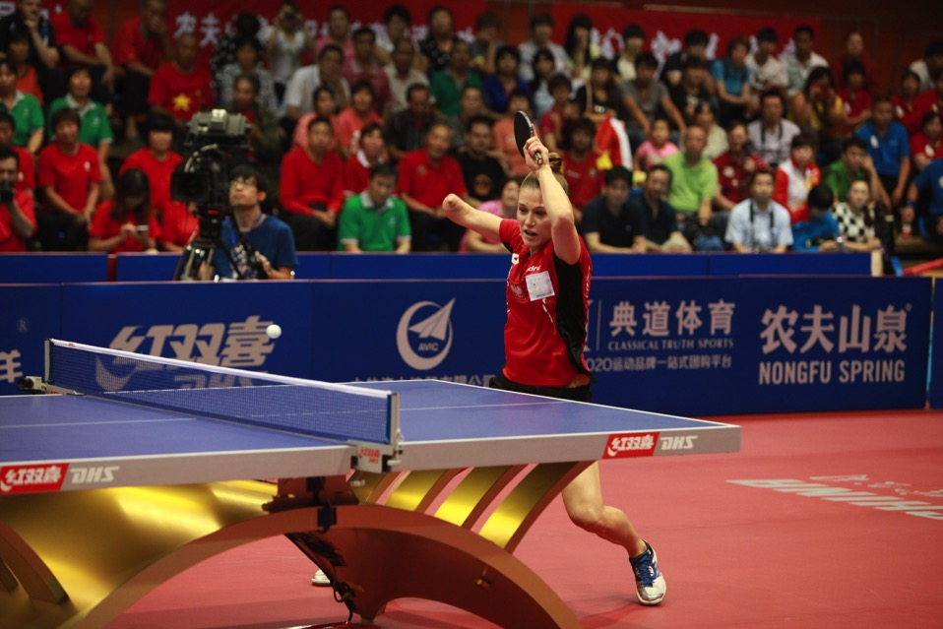
ABOUT THE DOCUMENT

The hosting rights of the 2017 ITTF Para Table Tennis Regional Championships are now available and open for application.

It will definitely be a valuable addition to your sporting calendar for the year, and we would like to invite all interested cities, associations and organisations to apply for the hosting rights. Please note that all applications must be submitted with the support of the respective National Table Tennis Association.

Applications for multiple years are also welcome. In this document you will find out more information on the events and brief hosting requirements.

To submit your application, please complete this application document form and attach any additional documents or information, such as hosting rights fees, which will help you in your application.

Please try to give as much details as possible to improve your application. It is fine if certain fields cannot be answered, but the more detailed the application the better chance of success.

Deadline
31 December 2015

Please send all documents by email to:

Ms Emese Barsai
ebarsai@ittfmail.com

Mr. Gorazd Vecko
gorazd.vecko@gmail.com

1. INTRODUCTION

Proposed Date  (DD MMM to DD MMM YYYY)  The Championships will be held over a period of (3-6) days. | Preferred Date:
 | Alternative Dates:
Place
City, Country
Events to be Included | Womens’ Team  Women’s Singles  Mens’ Team  Men’s Singles

Organization
Is your organization affiliated with official table tennis body?

If yes, please state Affiliated National/Provincial Association
(Table Tennis)
Contact Person
Position
Telephone
Email

Are you prepared to offer Visa to all qualified participants and accredited officials? | YES / NO
2. VENUE GENERAL INFO

Venue Name
Address
Nearest City
Nearest Airport
Contact Person
Position
Telephone
Email

Proposed Date For Venue Inspection
DD MMM YYYY

Spectators Capacity  Minimum 500 | Permanent Seating
 | Temporary Seating for additional capacity
Type Of Seats
Wheelchair Access
Parking Capacity
Is there air-conditioning?

If yes, will it affect play in the playing area and training area?

3. EVENT GENERAL INFO

Participation Capacity
(Hospitality etc.)
Hotel Name
Address
Website
International Standards
Star Rating

4. HOSTING GOALS & EVENT IMPACT

1. HOSTING GOALS
1.1 What are your goals and motivations for hosting the event?
1.2 What do you want to achieve by hosting this event?
1.3 How do you think this event can help you achieve your ultimate goal?
2. EVENT IMPACT & LEGACY
2.1 What are the impacts of the event on local & regional Table Tennis development – players, event organizational skills etc?
2.2 What are your main legacy plans for this event?
2.3 What other events or activities do you intend to organize to continue the momentum?

5. EVENT VENUE REQUIREMENTS

1. PLAYING AREA
Area  Minimum:  - 2 Show court & 10 Regular Competition Courts | Area (square meters) | m x m
Number of Show courts
(22m x 12m each)
Number of Regular Competition Courts
(14m x 7m each)
Lighting
Minimum 1,000 Lux
Flooring  synthetic subfloor  The organizer must ensure that the official sports flooring provided by the ITTF is used to cover all playing areas in the hall, installed on top of the synthetic subfloor. | YES / NO
Temperature
Main hall temperature during which event will be held.
Minimum: 16°C
Maximum: 25°C
Are there any windows or doors that can disturb players?
Yes/No. If yes, please detail plans to cover the windows or doors.
Wired Internet  Please indicate quantity and connection speed | Dedicated wired internet for Working Officials:  Quantity - Speed -  ***Dedicated 4 megabit SDSL internet line during the event according to itTV requirements OBLIGATORY
Wireless Internet
Yes/No. If yes, please indicate connection speed

2. TRAINING AREA
Training Area must be separated from Competition Area (separate hall/partitioned), but close by
Area size | m x m
Lighting
Lux
Flooring

Wireless Internet
Yes/No. If yes, please indicate connection speed
Is training area separated or partitioned?  Please indicate with “x”. | Separate Hall
 | Partitioned

3. CONTROL DESK
Location
Control desk is for officials who need full visibility and access to the playing area.

For example: in the main gym, above main gym but with visibility and easy access to courts etc.
Area size | m x m
Internet | Wired Internet | Upload Speed
 |  | Download Speed
 | Wireless Internet | Upload Speed
 |  | Download Speed

4. COMMENTARY BOX/DESK
Location
Please see attached TV Guide for more information on Commentator’s position requirements
Area size | m x m
Wireless Internet
Yes/No. If yes, please indicate connection speed

5. PLAYERS’ AREA
Player’s Lounge | Area Size | m x m
 | Refreshments Provided
Changing Rooms | Number For Men
 | Number For Women
Wireless Internet
Yes/No. If yes, please indicate connection speed

6. TECHNICAL OFFICIALS AREA
Referee and Umpire’s Lounge | Area Size | m x m
 | Refreshments Provided
Racket Control Room | m x m
Ball Selection Area | m x m
Wireless Internet
Yes/No. If yes, please indicate connection speed

7. MEDIA AREA
Draw & Press Conference Room | Area Size | m x m
Capacity
Number of people it can fit
Audio Visual Provided
At least 1 projector and screen required.
Wireless Internet
Yes/No. If yes, please indicate connection speed

8. OTHERS
What other relevant facilities are there?
Restaurant, Exhibition Space etc. Please indicate size and capacity.

6. VENUE & MATCH PRESENTATION

Dressing up the venue is important for the event to look professionally run to spectators as well as TV audiences. In this section, please outline your plans to dress up the venue.

1. FIELD OF PLAY
Lighting
(Eg. Spotlight on TV Table only, while other areas are kept dark etc.)
Music
(Eg. Professional DJ, Volunteer to control music etc.)
Entertainment between Matches
(Eg. Cheerleading, dances, songs, contests, engagement with spectators etc)
Dress Up
(Banners, backdrops, etc)
Screens
(Eg. Scoring, “Live” broadcast etc.)
Others

2. OUTSIDE FIELD OF PLAY
Results Board
(Digital/Non-digital)
To keep spectators updated on the event status.
Dress Up
(Banners, backdrops, signs, posters etc)
Others

7. TRANSPORT AND HOSPITALITY

1. TRANSPORT
Shuttle service between hotel and airport

Briefly estimate the number of buses, bus frequency and bus capacity. (wheelchair accessible)

Will there be a welcome person at the airport?
Shuttle service between hotel and venue

Briefly estimate the number of buses, bus frequency and bus capacity.
2. HOSPITALITY
Hotel Name
Stars
Address
Contact Person
Position
Telephone
Email
Distance to venue | Distance In Km
 | Time In Hrs & Mins
Distance to airport (km) | Distance In Km
 | Time In Hrs & Mins
Capacity | Single Rooms
 | Double Rooms
 | Triple (or more) Rooms
Meeting Rooms available?
Package Price/Room
What is the price of a standard room in full board you are proposing?
Welcome desk in lobby?
Yes/No. If yes, how many days and the opening hours per day.
Possibilities to put information board in hotel lobby?

8. TV PRODUCTION & BROADCAST

Will TV production be done by a TV Production company or a Host Broadcaster?
Please provide details such as company name, experience, etc.
HD TV Production  Most Broadcasters have a requirement for HD production in order to broadcast. Hence, producing in HD will greatly boost your application. | Yes / No
Number of Cameras
Number of Matches Planned for TV Production
Minimum production as per TV Guidelines
Local/Regional TV Broadcast Secured?

Please provide details such as broadcast hours, name etc.

TV Production can be costly if not bartered for TV rights. Please contact the ITTF if more information is required

9. MEDIA & PROMOTIONS

Please outline your promotional and media plans (prior to event and during event)
Will there be a dedicated Press Officer?
How many photographers will be available?
Please note that photos have to be named and uploaded after every match, or when there is a break between matches.

10. SUPPORTING PARTNERS

If you already have supporting partners to help your application, please indicate them below.

Company Name & Details | Support Role  (Eg. Grants given, Transport sponsored, Subsidized Flights etc.)

Thank you for completing this document. Please submit your application, including this application document form and attach any additional documents or information that will help you in your application by email to:

Ms. Emese Barsai
ebarsai@ittfmail.com

Mr. Gorazd Vecko
gorazd.vecko@gmail.com

Deadline
31 December 2015

International Table Tennis Federation
Marketing and Asia Pacific Headquarters
352 Tanglin Road #02-04/05, Singapore 247671
Tel: +65 6473 8022 Fax: +65 6473 8033

Website: ITTF.com
Facebook: Facebook.com/ITTFWorld
Twitter: @ITTFWorld
YouTube: YouTube.com/ITTFChannel

